Jornal 1
Live Tracking
Link:
http://103.133.167.11:8080/handle/123456789/3312
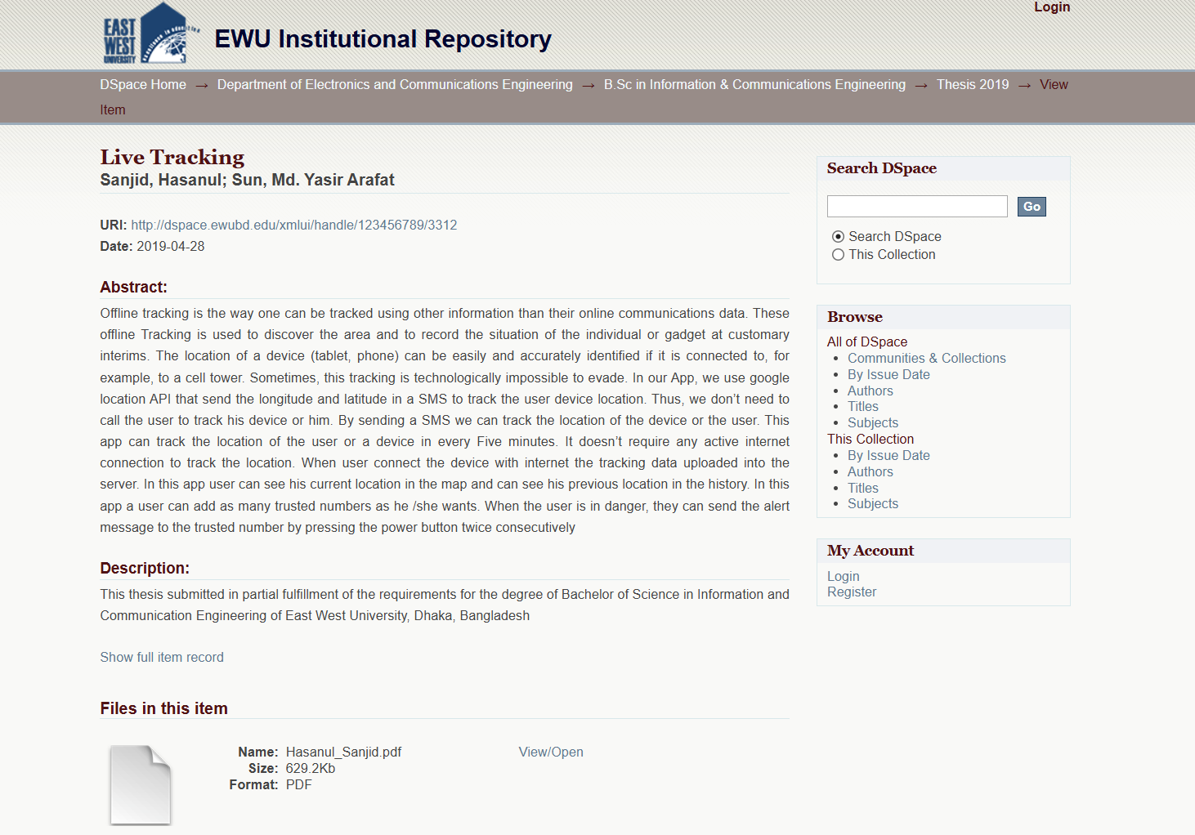
Erd:
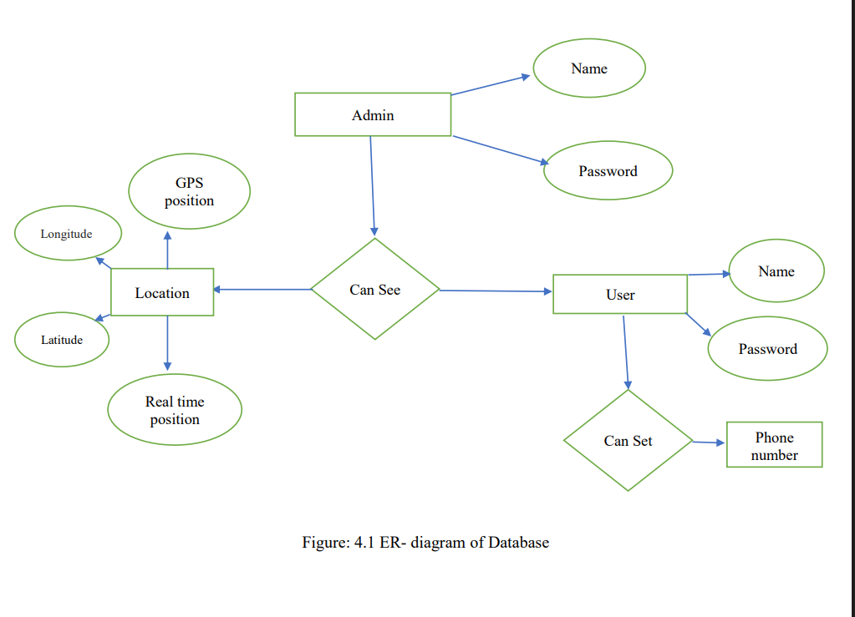
User- Name, Password
Admin-Name, password
Location-Gps position, longitude, latitude, real time position
Marketing Attributes:
Financial attributes:
Legal: phone number
Analytics Attributes: Longitude, latitude, gps position, real time position

Journal 2
Design and Implementation for Trucks Tracking System Using GPS Based on Semantic Web
Link:
https://d1wqtxts1xzle7.cloudfront.net/55569450/65_Design_and_Implementation_for_Trucks_Tracking_System.pdf?1738371296=&response-content-disposition=inline%3B+filename%3DDesign_and_Implementation_for_Trucks_Tra.pdf&Expires=1765102870&Signature=aPP1tPNaLyL-st8FsogTWQ9EPPP2~6yIUDkv2MlHFKgV3~NK5hwesz6~3rZPXuC1Qh4JJ3er9anLHeB3B6tnfJ9SJm-ag50KtR8~nTAsAwVmx~YnncSp4v6I69oCAuzz~jSTybBJfYbuyX0V9Z7kztY3DgLqqvg24HH2fuSeiJgDqVQEOYTlm~W3Febu4Kws70VsBi-49HizLI2IG8Wd0COuk~6qS~iSXP~8X~ltNlL~aUBk930K3T0HUGmf~nOv6caDZn46CprALIGtvBFScK8cYzGRju68wrgcLseGSXb5Dii9zQFtZRVXwXeN9V1pFYHbABgnuL3wAhEQ1IWP4A__&Key-Pair-Id=APKAJLOHF5GGSLRBV4ZA

Erd
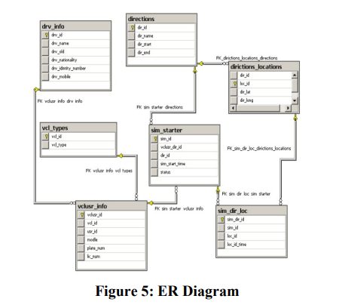

drv_info- drv_id, drv_name,drv_old, drv_nationality, drv_identity_number, drv_mobile
directions- di_id, dr_name, dr_start, dr_end
dirictions_locaions- dir_id, loc_id, dir_lat, dir_long
vcl_types- vcl_id, vcl_type
sim_starter- sim_id, vclusr_dir_id, dir_id, sim_start_time, status
vclusr_info- vclusr_id, vcl_id, usr_id, modle, plate_num, lic_num
sim_dir_loc- sim_dir_id, sim_id, loc_id, loc_id_time
Marketing attributes: modle, drv_mobile, vcl_type
Financial attributes:
Legal attributes: drv_identity_number, drv_old, lic_num, plate_num, drv_id, lic_num, plate_num, vcl_type
Analytics attributes: dir_lat, dir_long, dr_start, dr_end, loc_id, loc_id_time, sim_start_time, status, vcl_type, sim_id, loc_id_time

Journal 3
DATA MODELING FOR WEB-BASED MOBILE TRACKING SYSTEM OF INTERNALLY DISPLACED PERSON DURING CONFLICT
https://etd.uum.edu.my/6549/1/s816296_01.pdf

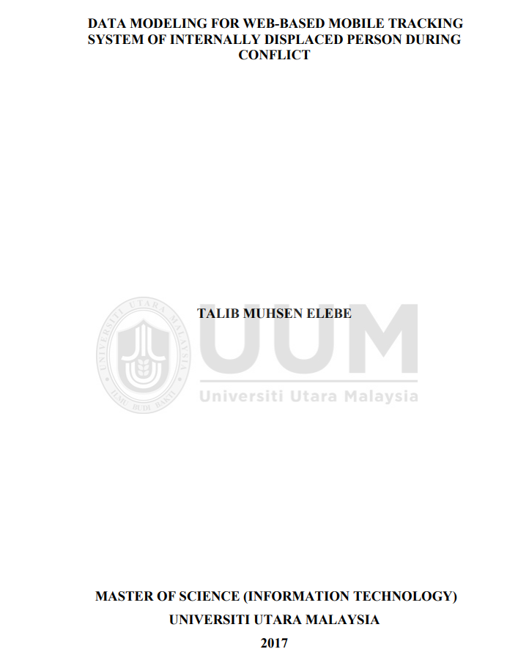

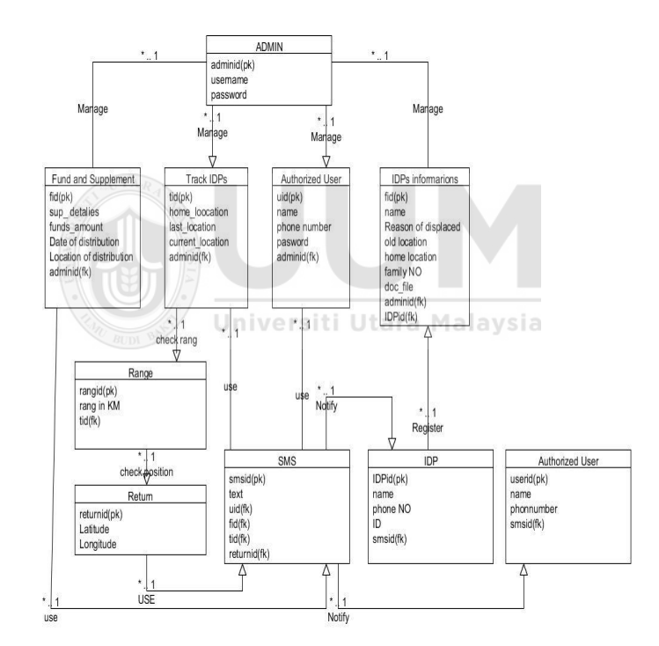
Admin- adminid, username, password
Fund and supplement- fid, sup_detalies, funds_amount, date of distribution, location of distribution, adminid
Track IDPs- tid, home_location, last_location, current_location, adminid
Authorized User- uid, name, phone number, password, adminid
IDPs informations- fid, name, reason of displaced, old location, home location, family NO, doc_file. Adminid, IDPid
Range- rangid, rang in KM, tid
Return- returned, latitude, longitude
SMS- smsid, text, uid, fid, tid, returned
IDP-IDPid, name, phone NO, ID, smsid
Authorized User- userid, name, phonenumber, smsid
Marketing attributes: phone number, text (SMS), location of distribution
Financial attributes: funds_amount, sup_details, location of distribution
Legal attributes: doc_file, IDPid, adminid, userid, fid, tid,
Analytics attributes: rang in KM, latitude, longitude, home_location, last_location, current_location, tid, smsid

Usecase diagram
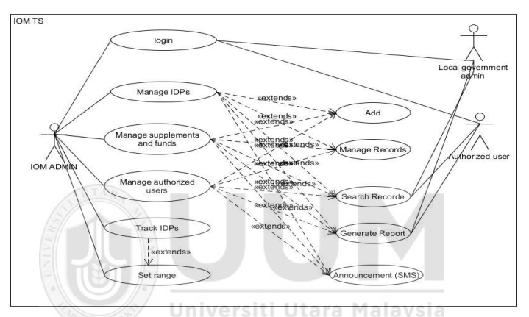

IOM ADMIN:
IOM ADMIN can login to the system
IOM ADMIN can manage the IDPs
IOM ADMIN can manage supplements and funds
IOM ADMIN can manage authorized users
IOM ADMIN can track IDPs
IOM ADMIN can set range

Local government admin:
Local government admin can login to the system
Local government admin can search report
Local government admin can generate report

Authorized user:
Authorized user can login to the system
Authorized user can search report
Authorised user can generate report

Journal 4:
GPS TRACKER DATA ANALYSIS PLATFORM
https://www.theseus.fi/bitstream/handle/10024/96330/Tinbit_Bekele.pdf?sequence=1&isAllowed=y
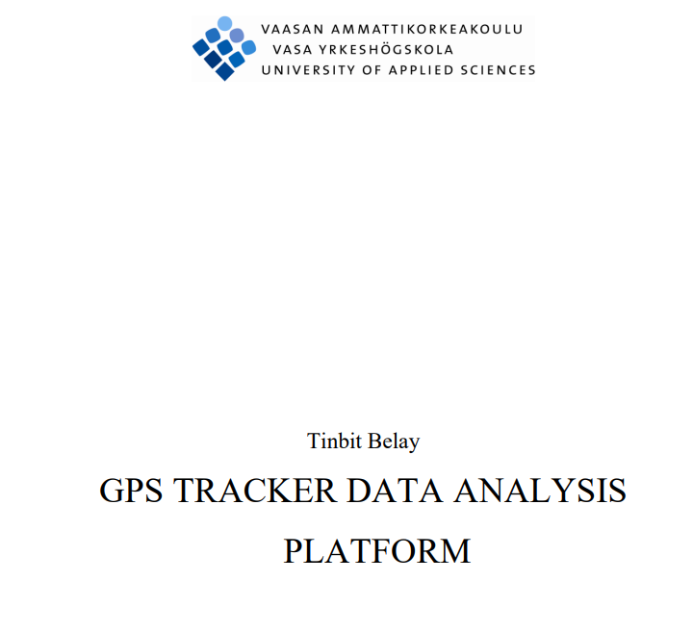
ERD:
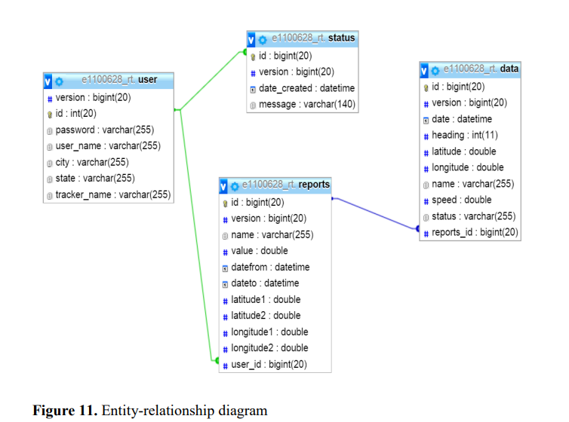
User- version, id, password, user_name, city, state, tracker_name
Status-id, version, date_created, message
Data- id, version, date, heading, latitude, longitude, name, speed, status, reports_id
Reports- id, version, name, value, datefrom, dateto, latitude1, latitude2, longitude1, longitude2, user_id
Marketing attributes:
Financial attributes:
Legal attributes: id, password, user_id, date_created, date,
Analytics attributes: latitude, longitude, latitude1, latitude2, longitude1, longitude2, speed, status, date, date_created, tracker_name

Use Case:
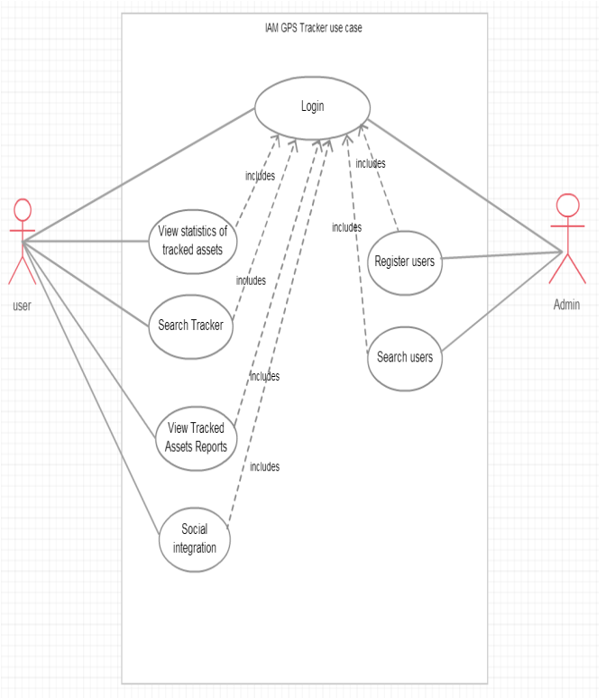
User:
User can login to the system
User can view statistics of tracked assets
User can search tracker
User can view tracked assts reports
User can social integration

Admin:
Admin can login to the system
Admin register users
Admin can search users

Journal 5:
User Requirement and Use Case Diagram for Traveler Tracking Application in Tourist Destination
https://repository.pnb.ac.id/id/eprint/6342/1/Artikel.pdf
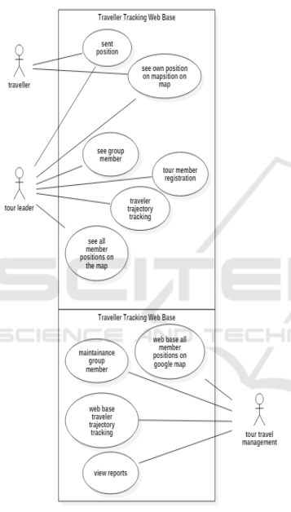
Traveller:
Traveller can send position
Traveller can see their own position on mapstition on map
Tour leader:
Tour leader can send position
Tour leader can see their own position on mapstition on map
Tour leader can see group member
Tour leader can see tour member registration
Tour leader can see traveler trajectory tracking
Tour leader can see all the member position on the map

Tour travel management:
Tour travel management can see web base all member position on google map
Tour travel management can maintain group member
Tour travel management can see web base traveler trajectory tracking
Tour travel management can view reports

Journal 6:
Development, Implementation, and Testing of a GIS & GPS based RealTime Vehicle Tracking System
https://netlibrary.aau.at/obvuklhs/content/titleinfo/2411795/full.pdf


Use Case:
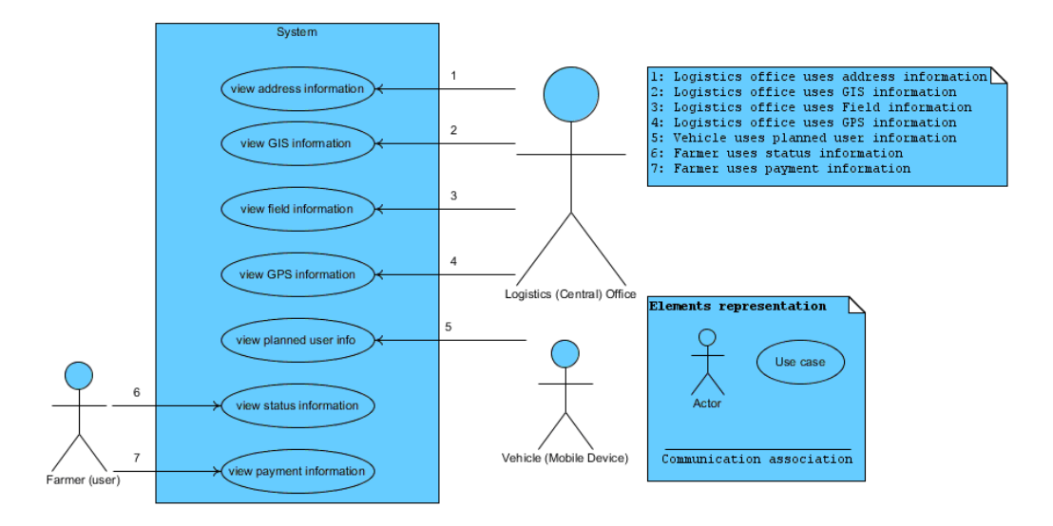
Logistics (Central) office:
Logistics (Central) office can view address information
Logistics (Central) office can view GIS information
Logistics (Central) office can view field information
Logistics (Central) office can view GPS information

Vehicle (Mobile device):
Vehicle (Mobile device) can view planned user info

Farmer(User):
Farmer(user) can view status information
Farmer(user) can view payment information

